SPRED
SPECIAL RELIGIOUS DEVELOPMENT
2956 South Lowe Ave. Chicago, Illinois 60616
Special 312-842-1039 www.spred-chicago.org
__________________________________________________________________________________________

February 2021 Volume 100, Number 2
_______________________________________________________________________________________________________________________________________
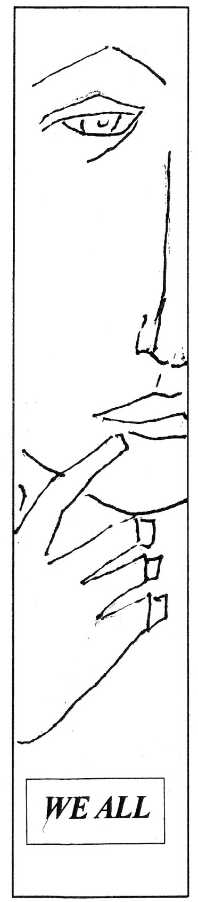
Within the past year or two, there has been some reflecting, or shall I say, some “soul searching” that I have been doing. In conversations and experiences I have had with fellow members of my religious community, my spiritual director, and even with faculty and staff at my graduate school, this “soul searching” has led me to ponder what does my own disability mean for me today and how does it affect me. When I was in grade school, I received accommodations and assistance for my speech-language disability. I used to take classes with a speech therapist to help improve my speech. By the time of middle school, all I needed was extended time on tests and assignments, which I still have available for me today.

In recent years, I have had my share of insensitivity from people who have had inaccurate assumptions about disabilities. Some of these inaccurate assumptions have included judgments about how well I can perform in class due to my own behavior. It is very humiliating and insensitive when people do this to me, especially when I am able to advocate for myself and share any needed information regarding my speech-language learning disability with them. I can only begin to imagine what it must be like for my friends in Spred who have their own disabilities and people at times see them as less than who they are. My own experiences has led me to try to do some digging into understanding the experience of people with disabilities, especially experiences like what I shared. In the past year, I have been reading up on the challenges that people with disabilities face, especially insensitivity.

In 2020, on the thirtieth anniversary of the passing of the Americans with Disabilities Act (ADA), the New York Times published a multi-series of articles relating to the ADA and the experiences of those who have disabilities. One such article in this series caught my attention, What Happens When You’re Disabled but Nobody Can Tell by Andrew Solomon. It was the first of such an article that really opened my eyes. Solomon makes a compelling point that typically when people think of the word “disability,” people think of ramps, automated doors, elevators and even accessible rest rooms. But when it comes to people on the Autism spectrum or those with mental illness, there can be disdain or assailment toward such people due to what others perceived from the greater society.1 When this happens, the common understanding is that the person “isn’t all there.” Typically, when it is discovered that this person has a disability, some people are more patient and understanding. Others may see that they may need to treat the person with a disability differently, as if the person can be “helped.” Even though Solomon has people with invisible disabilities in mind, this is also true for people with intellectual and developmental disabilities, like the friends we meet in Spred.

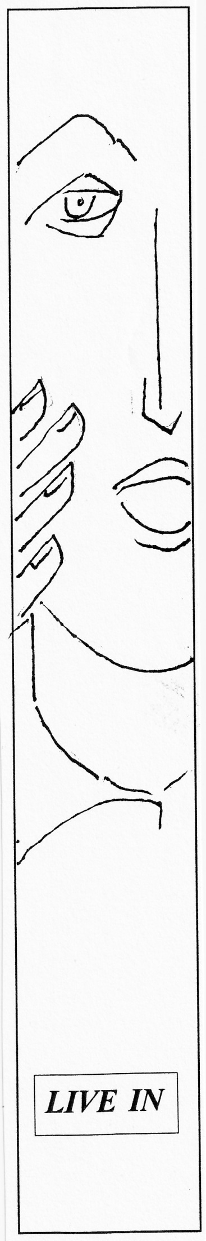
Sometimes we can get caught up in trying to “help others” and may believe that we have more to offer than what other people have to offer us. This can especially happen in Spred. I have heard numerous stories of catechists who thought they had something to offer our friends to only find out that there was something greater that the friends had to offer them. One catechist told me that the unconditional love and openness from the friends at Spred was so much greater than this catechist could ever offer to them. In a way, it brought conversion to the catechist. I have also experienced this.

In the first few months of starting with an adult Spred group, I was worried that I was not doing a good job with my friend. I felt like I was going nowhere and wasn’t accomplishing anything. One day during Agape, when I went to get more food for another friend and myself, the friend said to me, “thank you, you’re my buddy.” My own friend who I partner with said “no! He is my buddy!” I laughed a bit and was surprised. From that point on, my partner always called me his buddy. I then knew that it did not matter what I did. Just being present and open to my friend meant a lot. It was not about what I could do for my friend, it was a relationship that really mattered. It was this relationship that opened me to reflect more deeply.

My friend in my group and my experience of my whole time with Spred has led me to reflect and ask questions about disabilities. It has led me to wonder where disabilities fit in within the church and in theology. In society, there is an expectation that individuals are expected to contribute and work to keep the mechanism of society progressing. The assumption is if a person has a disability, the person cannot contribute. In the church, some people have assumptions that people with disabilities need to be healed to be able to participate in society and their local communities. Such expectations are not true and are misleading. They deny the human dignity of people with disabilities, especially our friends with intellectual and developmental disabilities.

In an article written by Heather Kim Lanier called “My daughter has a disability. I don’t want Jesus to ‘fix’ her,” she wrote about the challenges she faced raising her daughter who has an intellectual disability. After struggling with how to raise her daughter, she came to recognize that it did not matter what society and others in the community expected of her daughter, for her daughter was good, wholly, and created in the image of God like every other human being. Instead of her daughter needing to be healed, she writes, it is the concepts and beliefs that really need to be cleansed, that people with intellectual and developmental disabilities are less than, that they are unproductive or a burden, that having a disability is a curse or a calamity.2 It is concepts like these that can hinder growth and meaningful relationships.

What I have learned from being involved with Spred is that everyone gets something out of their experience. In my study of theology, this is called “mission in reverse,” which is when the evangelist or minister who goes to bring the Word to the people ends up being the one who receives the Word, or in this case, all the parties do. It is like a magic circle of sorts. The catechists and friends experience something. That something is grace and the experience of God being present. It is in that experience of transformation. Transformation happens when we recognize that our friends with intellectual and developmental disabilities have so much to offer us and not just what we can do for them. Insensitivity and our own assumptions can prevent transformation and the building of positive and enriching relationships with our friends.

Pope Francis has said that relationships can transform us. In his latest encyclical Fratelli
Tutti, Pope Francis writes about the Good Samaritan, that relationships, such as with our friends with intellectual and developmental disabilities I believe rings true for us at Spred, “evokes the interior struggle that each of us experiences as we gradually come to know ourselves through our relationships with our brothers and sisters.” 3 Relationships with anyone can challenge us.

Our friends in Spred are not challenging because they are “difficult.” They challenge us with our own woundedness and shortcomings. They challenge us to move beyond ourselves with what we know and perceive. That is why when we begin to see their openness, love, and everything they have to offer, our relationships with them create room for “our hearts expand as we step out of ourselves and embrace others.”4

Pope Francis has also spoken multiple times about people with disabilities and for the need for them to belong. On December 3rd, 2020 for the International Day of Persons with Disabilities, he put out a statement saying that people with various disabilities should not just be allowed to come to church, but also to receive the sacraments, be able to be trained as catechists, and should know that they are called to participate in the mission of the church.5

At Spred we already do what the pope asks and much more. We give our friends with intellectual and developmental disabilities not only a place where they can participate in the church and assist with the liturgy, but most importantly, a place to belong. Even now during this pandemic this is more important than ever.

The Covid 19 pandemic has changed our lives and the way we do things. Many of us are not able to meet face to face to protect one another and may feel isolated. If there is one thing this pandemic has revealed, it is that we need one another and need to foster our relationships. Zoom, social media, and other internet platforms have become important to help maintain our relationships with our family and friends. In the past year since the pandemic has begun, I have heard many stories from fellow catechists who have made use of these platforms to keep in contact with our friends in their Spred groups and some even got creative. Some have had online parties and others have had drive-by-Christmas caroling so that their friends know they are being thought of. These stories were very touching and even have made me hopeful for the future.

Even though we are still in the midst of the Covid-19 pandemic, let us not give up hope. Hope not just for the future and an end to Covid-19, but in God who loves and is present in our lives, especially in the lives of our friends with intellectual and developmental disabilities. Let us ask God to continue to give us guidance, to guide the mission of Spred, and to be present and help all of our friends with disabilities.
Brian M. Junkes
Chicago Spred Catechist and Member of the Society of Divine Word Missionaries

1. Andrew Solomon, “What Happens When You’re Disabled but Nobody Can Tell,” New York Times, July 26, 2020.
2. Heather Kim Lanier, “My Daughter Has a Disability. I Don’t Want Jesus To Fix Her,” America Magazine, May 15, 2017
3. Pope Francis, Fratelli Tutti: Encyclical Letter, On Fraternity and Social Friendship. Vatican City: Libreria Editrice Vaticana, 2020, #69
4. Pope Francis #89
5. Cindy Wooden, “Pope: Make Your Heart Accessible to People with Disabilities” Catholic News Service, Dec. 3, 2020

