SPRED
SPECIAL RELIGIOUS DEVELOPMENT
2956 South Lowe Ave. Chicago, Illinois 60616
Special 312-842-1039 www.spred-chicago.org
_______________________________________________________________________________________

May 2021 Volume 100, Number 5
___________________________________________________________________________________________________________________________________

One thing that Spred has taught me is to reflect on life using the framework of the Method Vivre. All Spred catechesis sessions have a familiar structure that helps the faith community to feel comfortable and to know what is coming next in the sequence of events. It starts with an evocation of a human experience that everyone can relate to. Remembering the details of this experience, including the concrete, physical attributes, the smell, the touch, the color and light - help us to bring the event, the story, or the object to life. The group will also naturally remember the feelings evoked by the memory of their own experience. The leader catechist tries to find a universal statement that describes our experiences and feelings. From there, the group will recall a liturgical experience that may evoke similar emotions. Then, a brief scriptural reading is proclaimed with simple words evoking God as our merciful father, Jesus as our guide, the Spirit as our inner help. God, Jesus and Spirit are accessible to us in our ordinary lives. We end catechesis with a message of Jesus speaking to each and every one of us. Our response of personal expression of praise and joy leads to a few moments of sacred silence.

I have found it helpful for me to reflect on my personal experience using this same framework. It begins with the descriptive light of the experience itself, the emotions that arise, the truth that the experience proclaims, the experience in the light of our faith traditions and Scriptures, and, finally, what Jesus is saying to me this day and my response. I have learned that this discernment does not promise specific answers or easy prescriptions to my problems. However, this way of living is full of surprise and insight and mystery, as we meet God in our everyday life. When a Spred faith community can do this together in a safe environment, it becomes a powerful expression of faith and church.

Those of us who have made a Spred Day of Reflection or a Weekend Retreat know that this prayerful discernment can be applied to a variety of themes or topics. In fact, it was at a weekend retreat that I first heard a long-time catechist, Kathy, suggest that this Method Vivre can be a way of life. For this newsletter, I have decided to reflect on one Spred group and our experience of the past year within this familiar Spred session framework.

The global pandemic has been an experience of loss, grief, and blessing for many of us in the past year. My Spred group has struggled to keep in contact with each other and to offer encouragement to each other. Our friends are adults with intellectual and developmental disabilities who live with their parents and others who live in group homes. Some are high functioning. All rely upon the structure and social opportunity offered to them through workshops or employment during the day. You can easily imagine the isolation, anxiety and frustration they have felt throughout the year.

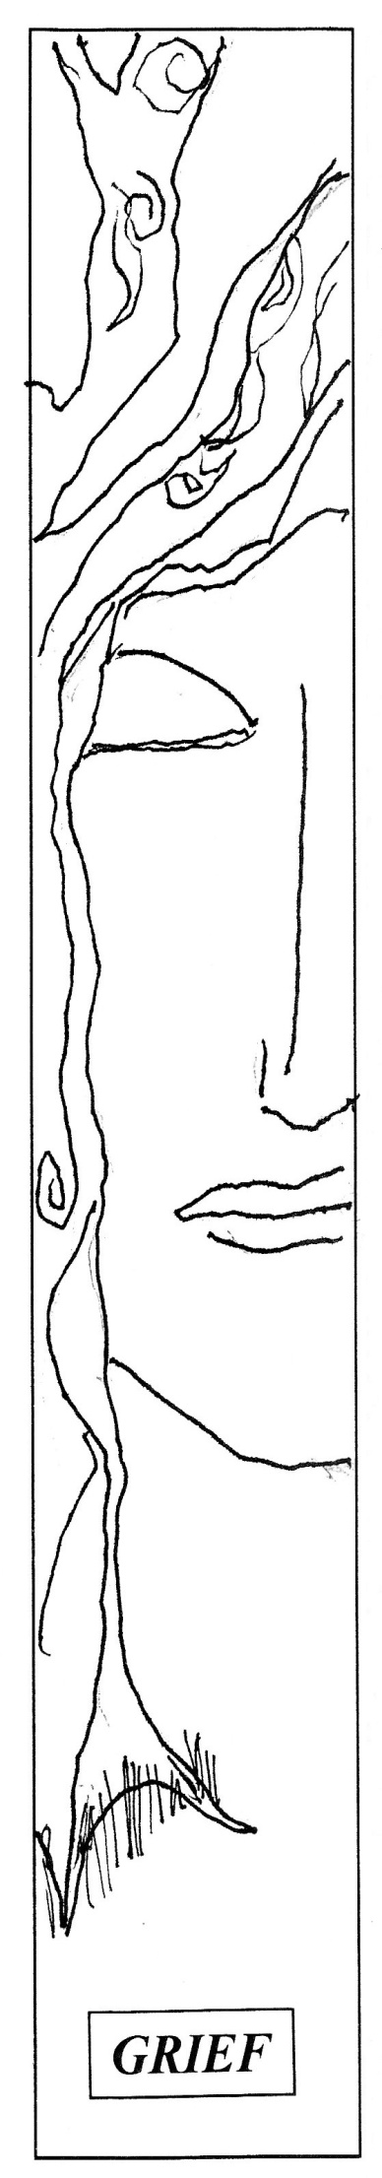
Our group of catechists includes some older adults with their own health concerns and difficulty in adapting to the new technologies of digital gatherings. Other catechists are still working and coping with the demands of full-time remote work. Parenting and grand parenting have also changed dramatically. With all of these new sources of stress, I have noted that most of us have grown at least a year older in the past 12 months! While we all have stayed safe from the coronavirus, we have suffered the loss of community connections and the ability to celebrate, worship, and lament together. We have lost the ability to connect with our families and friends in the ways to which we were accustomed. We have grieved through this loss. We have felt anger, denial, helplessness, anxiety and finally the acceptance that our world has changed. Who knows what changes have become permanent? I believe I have aged a few extra years in the past 12 months.

In the midst of these changes, our parish has been activated by the Renew My Church initiative of the Archdiocese of Chicago. This multi-year renewal process focuses on the vitality and the future of our parishes while considering the reality of available active priests and financial situations. Ultimately, we must ask what is best for the Church of Chicago. As a result many parishes are part of a discernment process to merge and share resources, especially if declining attendance or aging facilities warrant a change. Spred has a history of sharing across parish groupings, but it is very difficult for parishioners to welcome change to long-time places of worship.

However, we have been blessed - and blessed abundantly in the past year. We thank God for our health and safety. Like many Spred groups, we have tried to be creative with keeping connected. Our efforts have included a drive-by fundraiser for Spred, a Christmas car parade passed our friends’ homes, special deliveries of care packages, outdoor visits as allowed and phone calls/text messages with those who are able. I noted the responses of these modest efforts on the masked faces of our friends and their caregivers. In our friends, I saw the shock of disbelief and amazement that they were still remembered. They want to know when we can meet again and do the things we have always done. In the eyes of their caregivers and parents I saw twinkles of gratitude and appreciation. In the midst of this global pandemic, we have discovered that we are blessed. I feel grateful to my Spred faith community for their creativity, perseverance, and positive outlook. I feel touched by our friends who bear their burdens with grace - reminding me that my own burdens are not so heavy after all. It will be a joyful reunion when we can gather in-person again. This has been my Spred group’s experience in the past year.

There are many experiences of loss, grief and blessing in our world in the past year. When we reflect upon them, we can be with the loss and grief and know that life goes on. We can support and encourage and accompany each other. We feel the hope that comes with blessing. We can bless one another.

In our Christian tradition, new life is promised to us as believers. The paschal mystery celebrates Jesus’ passion and death, his resurrection and his ascension. We celebrate the Triduum at Easter - on Holy Thursday, Good Friday, and the Easter Vigil. These liturgies remind us that we are promised eternal life with the Father through Jesus. When we celebrate together as a faith community, we grow stronger in faith and we form a stronger community. We are happy to follow Jesus. In the Holy Book, Jesus taught us to pray, “Our Father in heaven, hallowed be your name, your kingdom come, your will be done, on earth as in heaven.” (Mt 6:9-10)
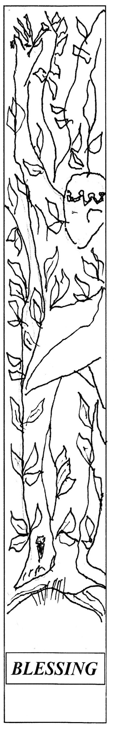
Jesus says to me today, “I am with you through joy and sorrow. Love one another as I have loved you.”

This framework is what I think of when I think about Spred. We begin with an evocation of a human experience. We recognize that this experience is specific to me and at the same time that it applies to everyone. We have all recognized loss, grief and blessing. Or we have all seen the beauty and mystery of a sunset. Or we have all known the feeling of being remembered on our birthday. However, those experiences can evoke completely different emotions and memories in each of us. As catechists, we help our friends and each other to align with the direction that the evocation of our experience is taking us. We probably do not wish to dwell on the time someone forgot it was our birthday.

We set this evocation side-by-side with our liturgical experience and faith traditions. We reach into our memory and understanding of a lifetime of ritual and worship in community. Like the evocation of the human experience, the evocation of the liturgical experience needs to be within the reach of our entire faith community. Shared experiences can evoke strong memories and emotions.

Similarly, we retrieve a simple scriptural reference that speaks to our theme. That verse or story can take on new significance in the light of our experiential and liturgical memories and emotions. Similarly, the human experience or our evocation of liturgy may seem different in the light of the other perspectives. This is where surprise and insight and mystery can be made known.

Ultimately, we can discern what God is saying to us through Jesus. As we have all experienced in our Spred sessions, something sacred occurs when the leader catechist addresses each person by name, holds their hands or touches their shoulders, and says “Jesus says to you today...” We are often surprised by our friends’ readiness to receive this message. Our response to this process is both personal and communal. We are joyful and thankful. We look forward to the banquet that Jesus promises us.

As a Spred faith community, we reflect on our experiences of the past year and see God’s presence in the midst of loss and grief. We look forward with hope and joy to the coming months and years, whatever they might bring.

As we have used the Method Vivre over the years in Spred, we are grateful to two French-speaking priests who developed it. One was from Diocese of Sherbrook, Quebec in Canada. He taught in the University of Sherbrook and was also the Director in a residence for teens with various disabilities. The other priest was from the Diocese of Lyons, France, who taught at L’Institut Catholique in Paris, France. He was also a chaplain in a residential facility in the south of France. The Canadian, Fr. Euchariste Paulhus and the French priest, Fr. Jean Mesny both worked with children, teens and adults with intellectual and developmental disabilities. They collaborated for many years to develop a method that respected many forms of intellectual functioning and as well as the renewal of catechesis. By taking time to explore the human experiences of both catechists and people with intellectual and developmental difficulties, they were delighted to see openings for faith development according to the capacities of each person.
Larry Adams
St. Denis Parish Spred Catechist, Chicago

A NEW SPRED TEAM MEMBER

As we continue to live in Easter Joy, we wish to share the good news that we have welcomed a new team member, Mary Ward, to be the Spred Administrative Assistant. Mary has been involved in Spred ministry as a catechist for over 25 years. She has been part of the training team to prepare new volunteers for their role as catechists. Added to her experience of growing in faith as a catechist she has administrative experience regarding the delivery of Spred information. As she writes in her application, "having been involved at the Spred Regional Resource Center as the web administrator, I have become familiar with the relationship and flow of information between the Spred Center, parishes and parish Spred groups." And even more important is her testimony that she "values and desires to further our effort to serve parishes, families and persons with intellectual and developmental disabilities."

And we, members of the Spred team say, "WELCOME, Mary!" We are grateful that you have chosen to continue your dedication to Spred ministry as Administrative Assistant. We rely on you to support our need to be well connected with those who share Spred ministry, those who wish to participate and those who wait to be welcomed into a parish Spred faith community.

